Member Satisfaction Survey Evaluation

A Member Satisfaction Survey which addressed quality, availability, and accessibility of care issues was mailed to all Jai Medical System members with HealthBeat, the member newsletter, in December 2020. The language and formatting of the survey was updated in 2020 to ensure that the survey adequately assessed the needs of our health plan. The CY 2020 survey consisted of 18 questions.

In 2020, the member satisfaction survey was reformatted and revised. The purpose of the changes were to be more consistent with the CAHPS survey design and to improve member comprehension. This was achieved by including clearer instructions (especially for conditional questions that require members to skip to another question on the survey) and added clarifying descriptors to certain questions that used terminology members may not be familiar with.

The purpose of the Member Satisfaction Survey is to measure and analyze member satisfaction and to identify areas that need improvement. Through survey results, Jai Medical Systems is able to identify issues, investigate sources of dissatisfaction, and implement action steps to follow up on the findings. This process is part of Jai Medical Systems’ continuing goal of improving the delivery of care and services to its members.

Member Satisfaction surveys are sent along with the member newsletters toward the end of the calendar year. The members are asked to fill out the survey and mail it back to Jai Medical Systems in the enclosed postage-paid envelope. A random sampling of 100 surveys that were received were used in the analysis. Once the sample size of 100 was met, any surveys that came in after that were counted but not included in the analysis. Any survey that was received that needed follow-up was forwarded to the appropriate department. When appropriate, a corrective action plan will be considered, developed, and monitored by the Quality Assurance Committee when performance standards are not met.

For CY 2020, a total of 20,000 surveys were mailed out, a random sampling of 100 survey responses were recorded and included in this analysis. In total we received 586 surveys. This is a response rate of 2.93%. All returned surveys were reviewed for responses and comments, and provided to the appropriate departments for follow up when necessary. Some surveys did not contain responses to some questions, so the denominator will vary by question.

Jai Medical Systems has established standards related to the Member Satisfaction Survey to evaluate our performance and identify areas of improvement. Member satisfaction survey performance standards for questions that measure satisfaction only are as follows:
- Less than a 5% “poor” rating
- Greater than or equal to a 85% combined rating for “Excellent” and “Good” responses
- Questions with a “Yes” or “No” response should have at least an 80% “Yes” response rate for questions directly related to satisfaction with care.

A corrective action plan will be considered for any survey responses that did not meet the above standards. Jai Medical Systems 2020 Member Satisfaction Survey results were reviewed to determine areas of strength and improvement. Jai Medical Systems received an overall satisfaction rate of 95% for CY 2020, which was 3.6 percentage points higher than the 2019 overall satisfaction rate of 91.4%. There were 2 survey questions that fell below our minimum standards and corrective action plans will be considered. The questions that did not meet our goals are listed in the chart below.

CY 2020 Survey Questions Below Standards

After arriving at your personal doctor's office for care, how would you rate the amount of time you waited before you see your personal doctor for a scheduled appointment | Excellent/Good | Poor
 | 80 | 2
 | 81% | 2%
After arriving at your personal doctor's office for care, how would you rate the amount of time you waited before you see your personal doctor without a scheduled appointment | Excellent/Good | Poor
 | 68 | 8
 | 73% | 9%

Survey Result Comparisons

In CY 2019, there were 5 survey questions that did not meet our minimum standards and corrective action plans were implemented. The chart below lists the 5 survey questions that required a corrective action plan and compares those questions to CY 2020 scores to see if improvements were made (positive changes are highlighted in green).

CY 2019 Corrective Action Plan Survey Questions Compared to CY 2020 Scores

Corrective Action Plan Survey Question | 2019 | 2020 | Change from CY2019 to CY2020
Customer Service skills of the medical staff and ability to assist with your questions | 78.9% (Excellent/Good)  6.1% Poor | 90% (Excellent/Good)  1% Poor | 11.1% increase  5.1% reduction
Knowledge of the medical staff and ability to assist with your questions | 82.8% (Excellent/Good) | 93% (Excellent/Good) | 10.2% increase
After arriving at your doctor's office for care, how would you rate the amount of time waiting before you see your doctor for a scheduled appointment? | 73.3% (Excellent/Good)  8.8% (Poor) | 81% (Excellent/Good)  2% (Poor) | 7.7% increase  6.8% reduction
After arriving at your doctor's office for care, how would you rate the amount of time waiting before you see your doctor without an appointment? | 65.7% (Excellent/Good)  10.2% (Poor) | 73% (Excellent/Good)  9% (Poor) | 7.3% increase  1.2% reduction
How would you rate your ability to get an appointment with a specialist? | 81.8% (Excellent/Good) | 92% (Excellent/Good) | 10.2% increase

Recommendations

It is recommended that the following survey questions be discussed during the QAC to request Corrective Action Plans:

- After arriving at your personal doctor's office for care, how would you rate the amount of time you waited before you see your personal doctor for a scheduled appointment?
  - 81% “Excellent/Good” combined responses
- After arriving at your personal doctor's office for care, how would you rate the amount of time you waited before you see your personal doctor without a scheduled appointment
  - 73% “Excellent/Good” combined responses

The 2 CY 2020 survey questions with a response rate below our minimum standards will be discussed at the QAC. Additionally, our overall satisfaction has increased by 3.6 percentage points since 2019. Overall, member satisfaction survey results increased. This may be due to the reformatting of the member satisfaction survey to be more user friendly. We included clearer instructions and added clarifying descriptors to certain questions to improve member comprehension.

2020 Consumer Assessment of Health Plans Survey (CAHPS®) Evaluation
As part of the federally required quality assurance plan, the Maryland Department of Health (MDH) conducted annual surveys to measure adult and child satisfaction with the services provided by the managed care organizations participating in the HealthChoice program. MDH contracted with The Myers Group, a National Committee for Quality Assurance (NCQA) certified vendor, to conduct satisfaction surveys for the 2004, 2005, 2006, and 2007 reports. In 2008, 2009, 2010, 2011, and 2012 MDH contracted with WB&A Market Research to complete the CAHPS® 4.0H for child enrollees in HealthChoice and 4.0H for adult enrollees in HealthChoice. In 2013, NCQA released the 5.0H version of the CAHPS® Adult Medicaid Satisfaction Survey, which was adopted by MDH. In 2013, 2014, 2015, 2016, and 2017 MDH continued their contract with WB&A Market Research, however the CAHPS® 5.0H surveys were used for both the HealthChoice child and adult surveys. In 2017, MDH contracted with the Center for the Study of Services (CCS), to administer and report the results of the 2018 CAHPS® Adult Medicaid Satisfaction Survey. MDH continued their contract with CCS in 2020. These surveys are important to determine the members’ ratings of and experiences with the medical care they received. It should be noted that the survey fielding period coincided with the rise of the COVID-19 pandemic. Survey results should be interpreted with caution because data collection took place during the height of the COVID-19 pandemic. The impact of the pandemic on member health experience is difficult to measure.

Impact of COVID-19 on NCQA Rating
In response to the COVID-19 pandemic, NCQA permitted health plans and vendors to depart from the standards CAHPS data collection protocol as needed by reducing the number of mailings and/or telephone attempts, replacing the telephone interviewing portion of the protocol with an additional survey mailing, or stopping data collection entirely. NCQA acknowledged that a multitude of factors, such as wide regional variation in COVID-19 infection rates, consumer experience, stay-at-home orders, social distancing guidelines, difference in vendor practices and staffing models, “essential business” designations, and protocol decisions made by individual health plans might compromise the quality and validity of the data collected. In April, NCQA announced that due to COVID-19:

- It would not be publishing 2020 Health Plan Ratings for any product line.
- Accredited commercial and Medicaid plans would still be required to submit HEDIS and CAHPS measures to NCQA in order to meet annual reporting requirements.
- Organizations would not be rated on measure results.

CAHPS® Survey Reports
There are three groups of member satisfaction results available from CAHPS® surveys. These are the CAHPS® 5.0H Adult Medicaid HealthChoice results, the 5.0H Medicaid Child HealthChoice results and the 5.0H Medicaid Child with Chronic Conditions (CCC) results. Within each of these types of surveys, there are particular categories of questions reported that are specific to the type of care a member receives.

Adult HealthChoice
Within the CAHPS® 5.0H Adult Medicaid HealthChoice survey, there are four overall satisfaction questions and seven composite score categories made up of multiple similar questions. The four overall satisfaction questions include a rating of the Personal Doctor, Specialist, Health Care Overall, and Health Plan Overall. The composite score categories include Getting Needed Care, Getting Care Quickly, How Well Doctor Communicates, Customer Service, and Coordination of Care. NCQA shortened the 2020 HEDIS/CAHPS 5.0H surveys to reduce the burden for health plan members and sponsors. In 2020, the following questions were removed from the survey: Shared Decision-Making, Health Promotion and Education, Written Materials or Internet Provided Needed Information question, and Chronic Conditions.

Child HealthChoice (General Population and Children with Chronic Conditions)
The CAHPS® 5.0H Child Medicaid (with CCC) Survey was distributed to all eligible members 17 years of age and younger. These survey results contain two categories of children: the general population and children with chronic conditions (CCC). The general population includes all children enrolled in HealthChoice, including those with chronic conditions. The CCC population separates and analyzes the results of only those children with chronic conditions. The general population and CCC population are surveyed on the same questions regarding their care; however, an additional five composite measures, specific to the CCC population, are included in the CCC survey. The overall satisfaction questions that are identical between the two populations are ratings on Personal Doctor, Health Plan, Specialist, and Health Care. The identical composite measures between the two populations include Getting Needed Care, Getting Care Quickly, How Well the Doctor Communicates, and Customer Service.
The additional five composite measures for the CCC population include: Getting Needed Information, Personal Doctor Who Knows Child, Access to Prescription Medication, Coordination of Care for Children with Chronic Conditions, and Access to Specialized Services.
In 2020, the following questions were removed from the survey: Shared Decision-Making, Health Promotion and Education.

CAHPS® Satisfaction Survey Analysis
Within each of the reports presented by CCS, there are multiple analyses of the results. The member ratings for each individual question are included, as well as comparisons to previous years, if available and a comparison to the HealthChoice aggregates. Detailed Performance Charts are provided for the rating questions and composite measures. Demographic analyses are presented at the beginning of the data to understand the sample size. Key drivers are discussed as well, indicating which specific measures are of high enough importance to drive the members to rate their overall health plan and overall health care as high, moderate, or low on the survey.

Detailed Performance Charts
CCS was able to include detailed charts for composite global proportions, rating question summary rates (QSRs), as well as additional QSRs for individual survey items. The charts trended scores over three consecutive years of data, and statistical comparisons between current-year rate and each of the prior-year rates, if available.

Demographic Analysis
CCS was able to include a demographic analysis along with the CAHPS® results. This analysis includes the health status, age, gender, level of education, and ethnicity/race of the members. Respondents were allowed to choose more than one ethnicity; therefore the ethnicity percentages may be over 100%.

Adult HealthChoice
- 67.0% rate their overall health at excellent, very good or good
- 71.2% rate their mental/emotional health at excellent, very good or good
- 46.2% female; 53.8% male
- 63.8% of members obtained an education of high school or less
- 81.7% African American; 14.2% White; 1.8% Hispanic/Latino; 2% Asian; 0.4% Native Hawaiian/other Pacific Islander; 0.4% American Indian or Alaska Native

Children HealthChoice (General Population)
- 97.8.0% rate their overall health status at excellent, very good, or good
- 92.3% rate their mental/emotional health at excellent, very good, or good
- 38.5% female; 61.6% male
- 45.8% of the children have a parent/guardian with a high school education or less
- 65.7% African American; 23.8% White; 6.7% Hispanic; 10.5% Asian; 1% Native Hawaiian/other Pacific Islander, 3% American Indian or Alaska Native

Comparison to Aggregates
The Adult Medicaid HealthChoice and Children Medicaid survey results are compared to an aggregate of HealthChoice survey results in the state of Maryland. The following tables compare the results of survey overall ratings and composite measure scores between JMSMCO and the state aggregate. JMSMCO’s score is bolded if it was equal to or higher than the Maryland Aggregate.

Table 21: CAHPS® Results Comparison – HealthChoice Adult
Adult Medicaid HealthChoice
 | 2020 | HC Aggregate
Getting Needed Care | 85% | 84%
Getting Care Quickly | 86% | 84%
How Well Doctor Communicates | 94% | 93%
Customer Service | 92% | 90%
Coordination of Care | 89% | 84%
Health Care Overall | 52% | 54%
Personal Doctor | 72% | 66%
Specialist | 70% | 66%
Health Plan Overall | 56% | 57%

Table 22: CAHPS® Results Comparison – HealthChoice Children
Children Medicaid (General Population)
 | 2020 | HC Aggregate
Getting Needed Care | 85% | 85%
Getting Care Quickly | 92% | 89%
How Well Doctor Communicates | 98% | 96%
Customer Service | 90% | 89%
Coordination of Care | 97% | 85%
Health Care Overall | 82% | 71%
Personal Doctor | 89% | 78%
Specialist | 73% | 73%
Health Plan Overall | 74% | 70%

Table 23: CAHPS® Results Comparison – Children with Chronic Conditions
Children Medicaid (CCC Population)
 | 2020 | 2019 HC Aggregate
Getting Needed Care | 87% | 87%
Getting Care Quickly | 94% | 93%
How Well Doctor Communicates | 98% | 94%
Customer Service | 93% | 90%
Coordination of Care | 93% | 84%
Access to Prescription Medication | 95% | 92%
Access to Specialized Services | 84% | 77%
Family Centered Care: Personal Doctor Who Knows Child | 96% | 91%
Family Centered Care: Getting Needed Information | 92% | 91%
Coordination of Care for Children with Chronic Conditions | 64% | 77%
Health Care Overall | 75% | 69%
Personal Doctor | 90% | 77%
Specialist | 55% | 74%
Health Plan Overall | 68% | 68%

TOP PRIORITIES FOR QUALITY IMPROVEMENT

CSS’s Key Driver Analysis identifies the areas of health plan performance and aspects of member experience that shape members’ overall assessment of their health plan. To the extent that these specific areas or experiences can be improved, the overall rating of the plan should reflect these gains.

Adult HealthChoice
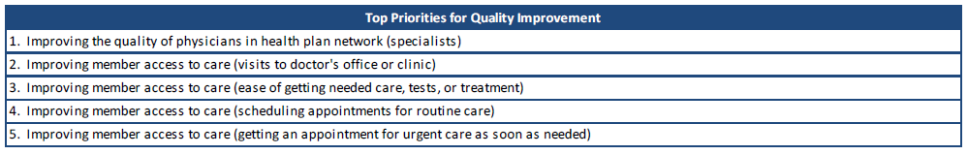

Child HealthChoice (General Population and Children with Chronic Conditions)
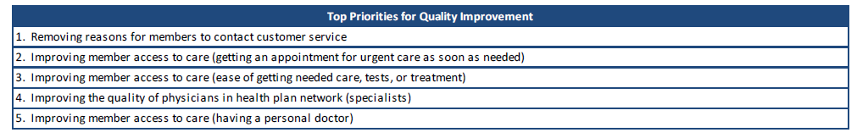
Five-Year Trend Comparisons
Five-year trend comparisons are available for most of the Adult Medicaid HealthChoice program and the Child Medicaid programs. The trend comparisons look at the overall ratings (health plan, health care, personal doctor and specialist) as well as the composite measures that are specific to each type of survey.

Adult HealthChoice

Figure 5: Overall CAHPS® ratings - HealthChoice Adult

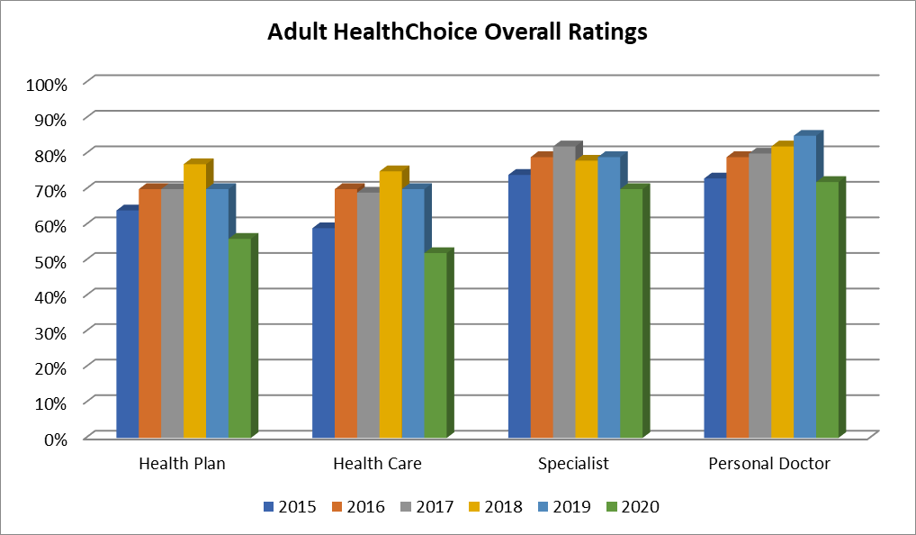

Figure 6: CAHPS® Ratings for Composite Measures - HealthChoice
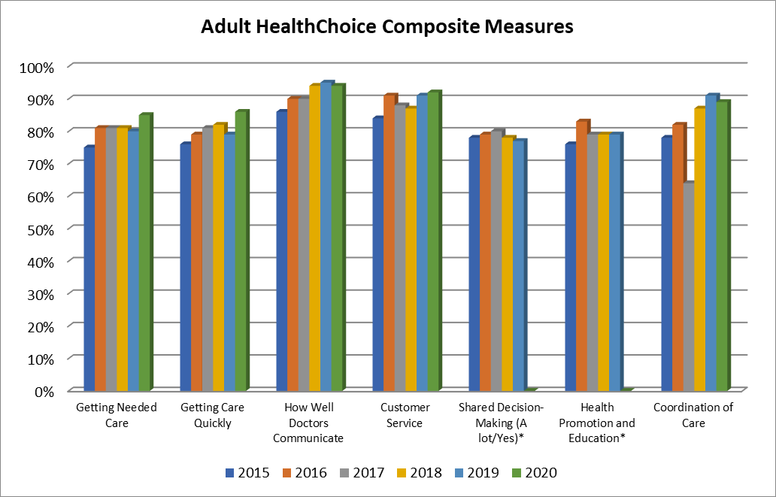

Children (General Population)

Figure 7: CAHPS® Overall Ratings – HealthChoice Children

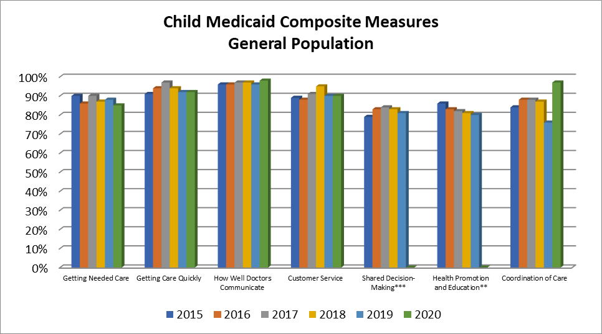

Figure 8: CAHPS® Ratings for Composite Measures – HealthChoice Children

Two measures (Shared Decision-Making and Health Promotion and Education) were significantly changed in 2013 and are not comparable to scores collected previous to this change.

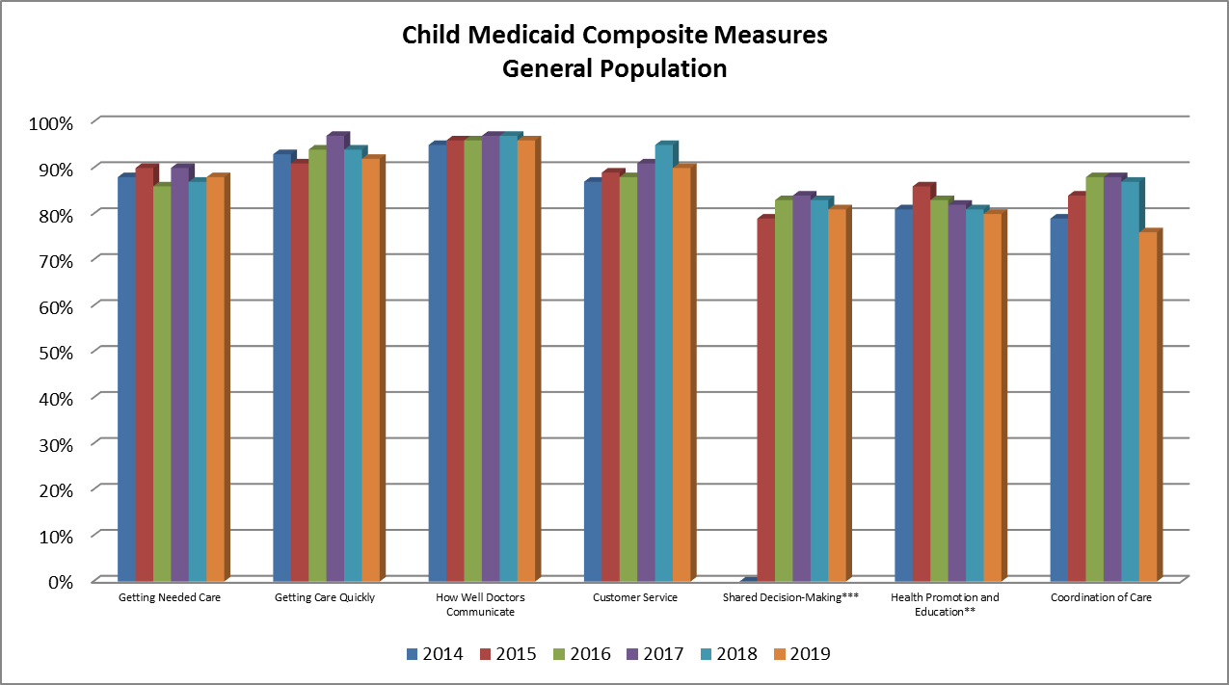

Children (CCC Population)

Figure 9: CAHPS® Overall Ratings – HealthChoice Children with Chronic Conditions

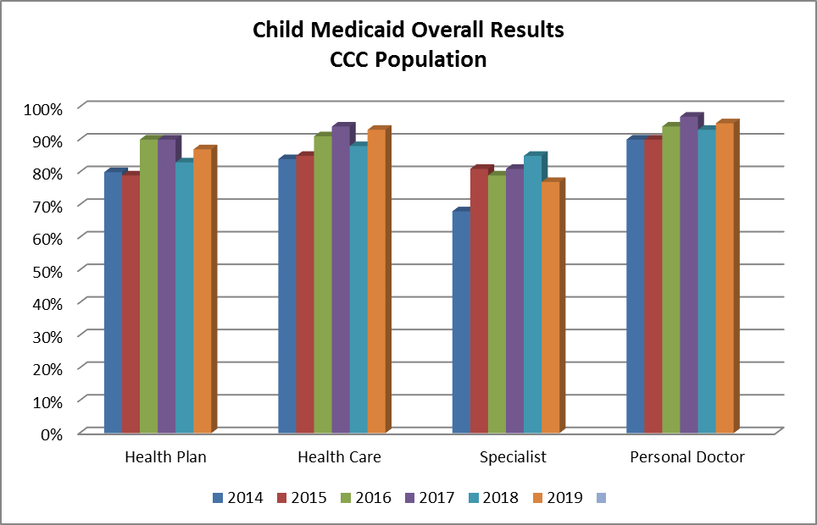

Figure 10: CAHPS® Ratings of Composite Measures – HealthChoice Children with Chronic Conditions

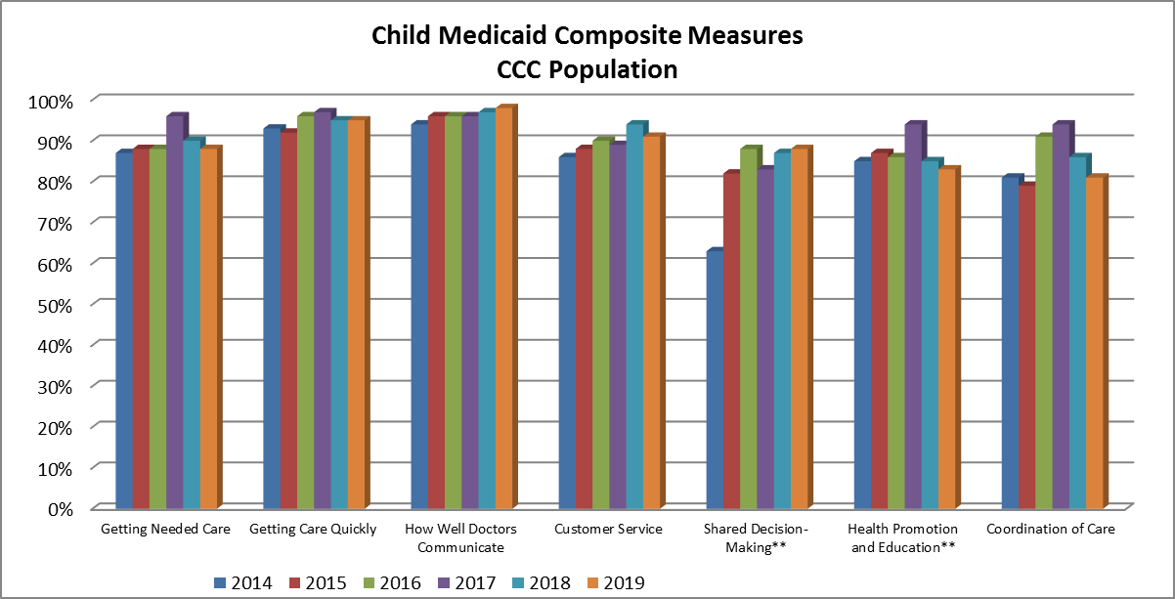

Figure 11: CAHPS® Ratings of Composite Measures Specific to Children with Chronic Conditions

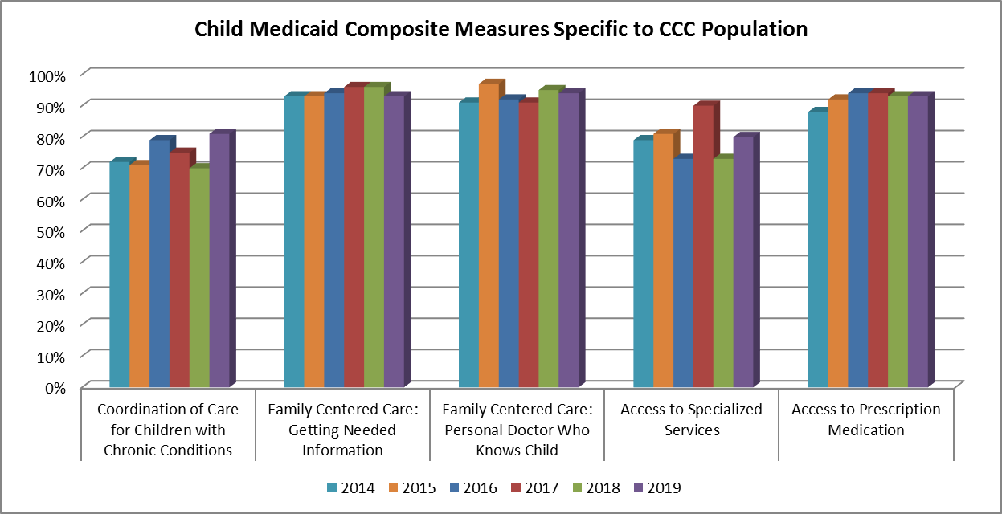

2020 Jai Medical Systems Adult Medicaid CAHPS Survey: Summary of Results
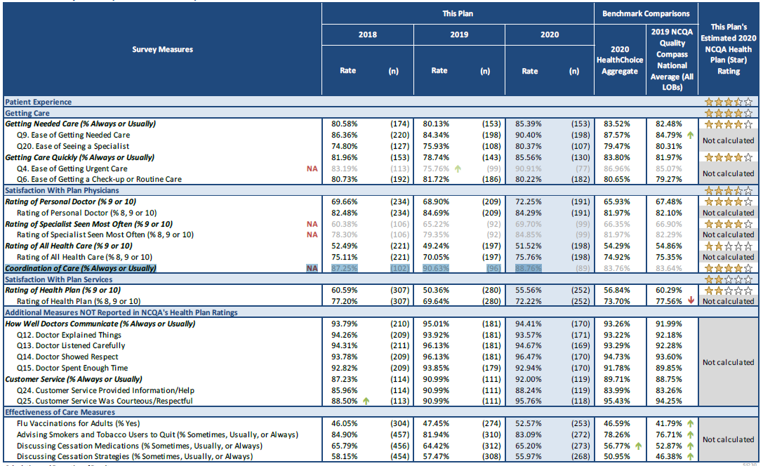

2020 Jai Medical Systems Child Medicaid CAHPS Survey: Summary of Results

